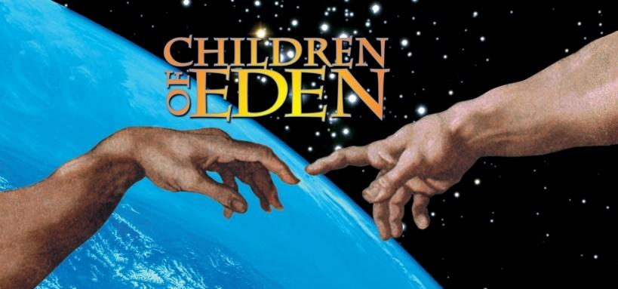
Cast List
Adam / Noah Nolan Livesay
Eve / Mama Noah Sarah Ayotte
Cain / Japheth Alfonzo Garcia
Abel / Ham Chazz Duran
Father Jason Livesay
Yonah Kaelyn Kilpatrick
Seth / Shem Gabe Falatea
Aphra Tai Dooley
Aysha Leilani Baldwin
Snake (5) Julia Axelrod, Meigan Heinrich, Leilani Baldwin, Kaelyn Kilpatrick, Tai Dooley
Ensemble
Tai Dooley, Gabe Falatea, Meigan Heinrich, Andrew Lizotte, Leilani Baldwin, Julia Axelrod

Act I
- *Let There Be – Father & Full Company
- Perfect (Part 1) – Storytellers, Father, Adam & Eve
- The Tree of Knowledge – Father & Adam
- The Naming – Father, Adam, Eve & Storytellers
- Grateful Children – Adam & Eve
- Father's Day – Father
- Perfect (Part 2) – Storytellers, Father, Adam & Eve
- The Spark of Creation – Eve
- *In Pursuit of Excellence – *Snake & Eve
- The End of a Perfect Day – Storytellers
- Childhood's End – Storytellers, Father & Eve
- A World Without You – Adam, Father & Eve
- The Expulsion – Father & Storytellers
- The Wasteland – Storytellers
- Wilderness Family – Adam, Young Cain & Young Abel
- The Spark of Creation (Reprise 1) – Eve
- Lost in the Wilderness – Cain & Abel
- Lost in the Wilderness (Reprise) – Cain
- Close to Home – Adam, Eve, Abel, Young Cain & Young Abel
- A Ring of Stones – Adam, Eve, Cain & Abel
- Clash of the Generations – Adam, Eve, Cain & Abel
- The Death of Abel – Eve & Storytellers
- The Mark of Cain – Father & Storytellers
- Children of Eden – Eve & Full Company
Act II
- Generations – Storytellers
- The Gathering Storm – Noah & Father
- A Piece of Eight – Storytellers, Noah, Mama Noah, Japeth, Yonah, Ham, Shem, Aphra & Aysha
- Blind Obedience – Noah
- The Return of the Animals – Orchestra
- The Naming (Reprise)/Noah's Lullaby – Storytellers & Noah
- Stranger to the Rain – Yonah
- In Whatever Time We Have – Japeth & Yonah
- The Flood – Father & Storytellers
- What is He Waiting For? – Noah, Mama Noah, Japeth, Ham, Shem, Aphra & Aysha
- Sailor of the Skies – Yonah
- The Spark of Creation (Reprise 2) – Mama Noah
- The Hardest Part of Love – Noah & Father
- Words of Doom – Storytellers
- The Hour of Darkness – Noah, Mama Noah, Japeth, Yonah, Ham, Shem, Aphra & Aysha
- Ain’t it Good? – Mama Noah & Full Company
- Precious Children – Father
- In the Beginning – Japeth, Yonah, Noah, Mama Noah, Father, & Full Company
A song with an asterisk (*) before the title indicates a dance number; a character listed in a song with an asterisk (*) by the character's name indicates that the character exclusively serves as a dancer in this song, which is sung by other characters.

